**Skilling-3**

**Hospital Rating Analysis**

**To Rate the Hospitals based on its performance by EDA**

1. Loading data & cleaning

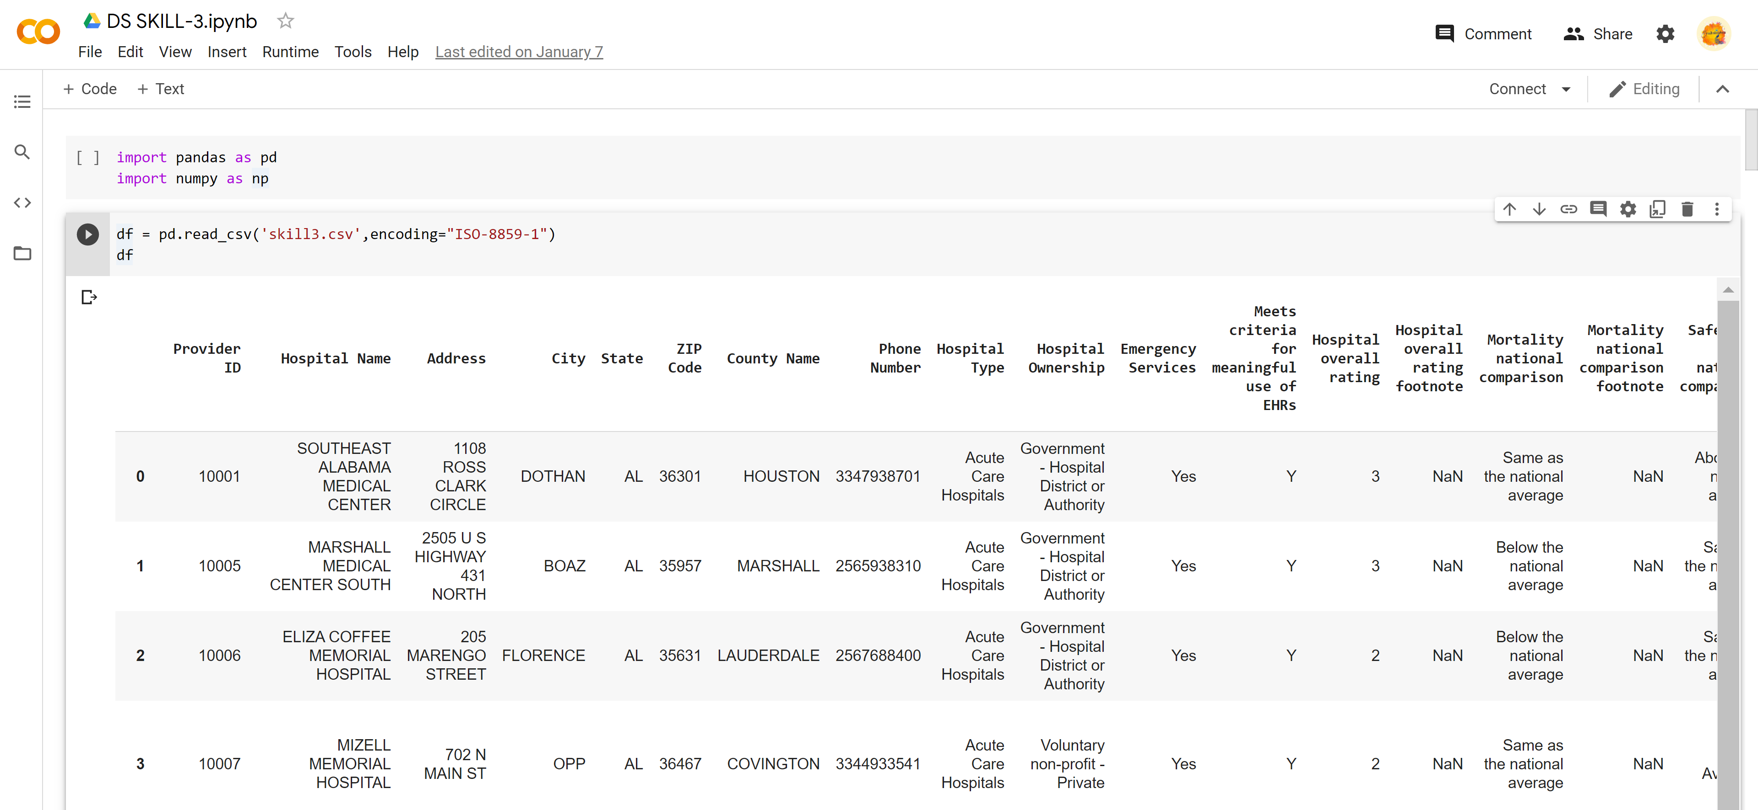

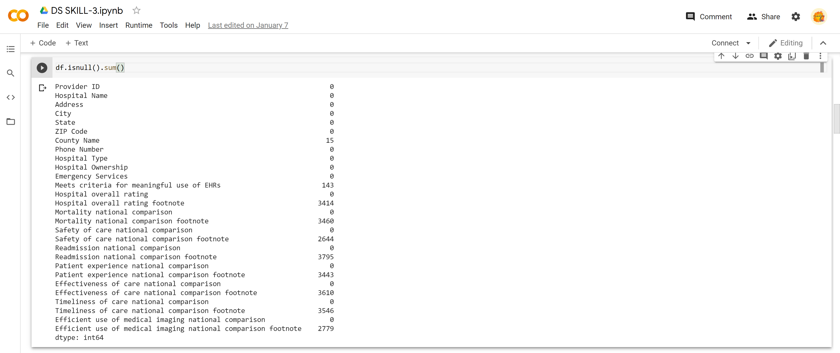



1. Hospital Analysis-‘[Hospital Type’ by ‘Ownership](https://www.kaggle.com/gsdeepakkumar/hospitals-an-analysis" \l "hospital-type-by-ownership" \t "_self)’

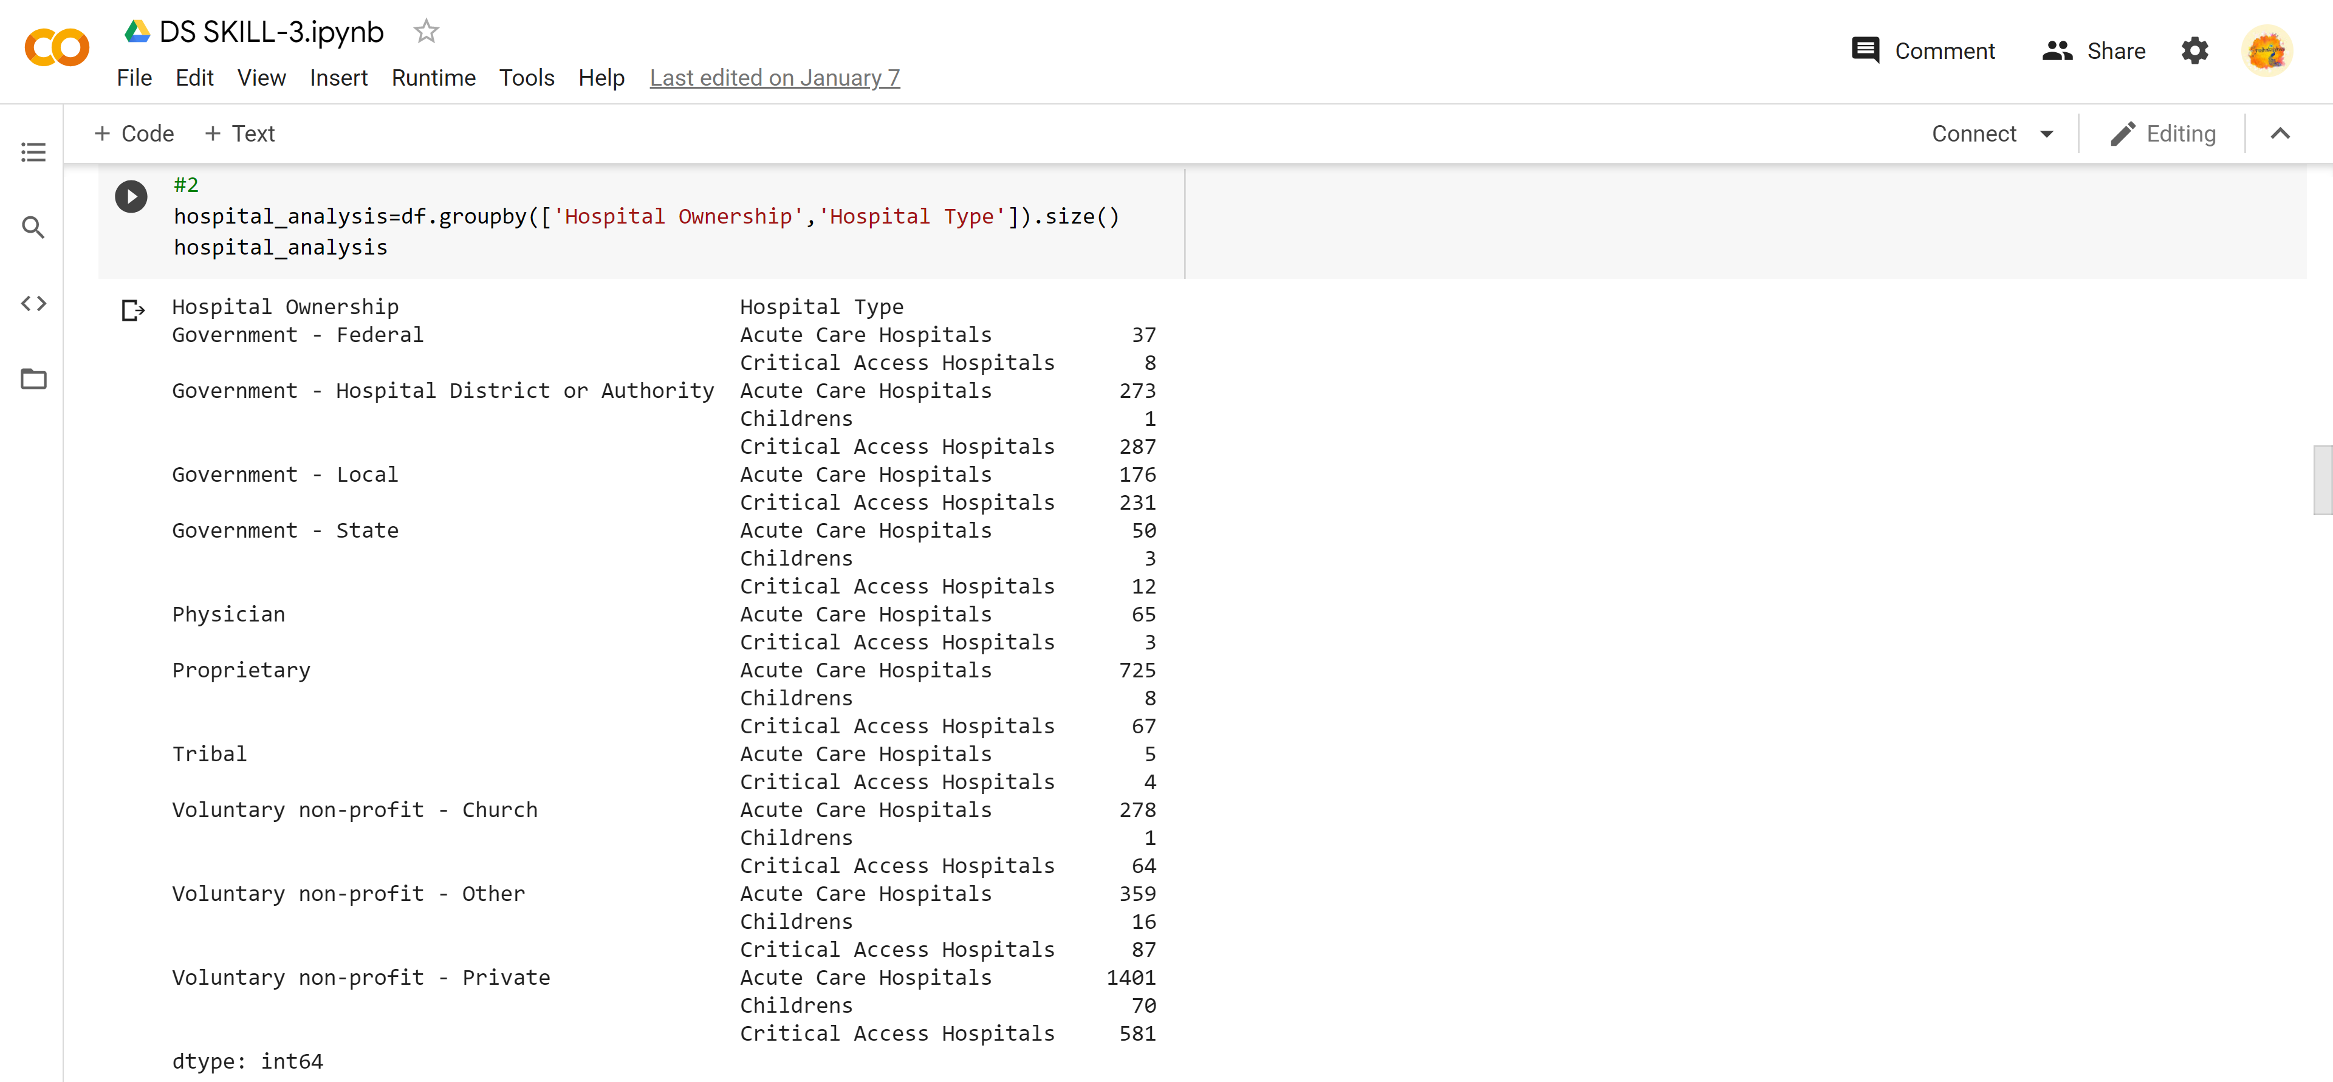

1. Total number of Hospitals in each ‘State’

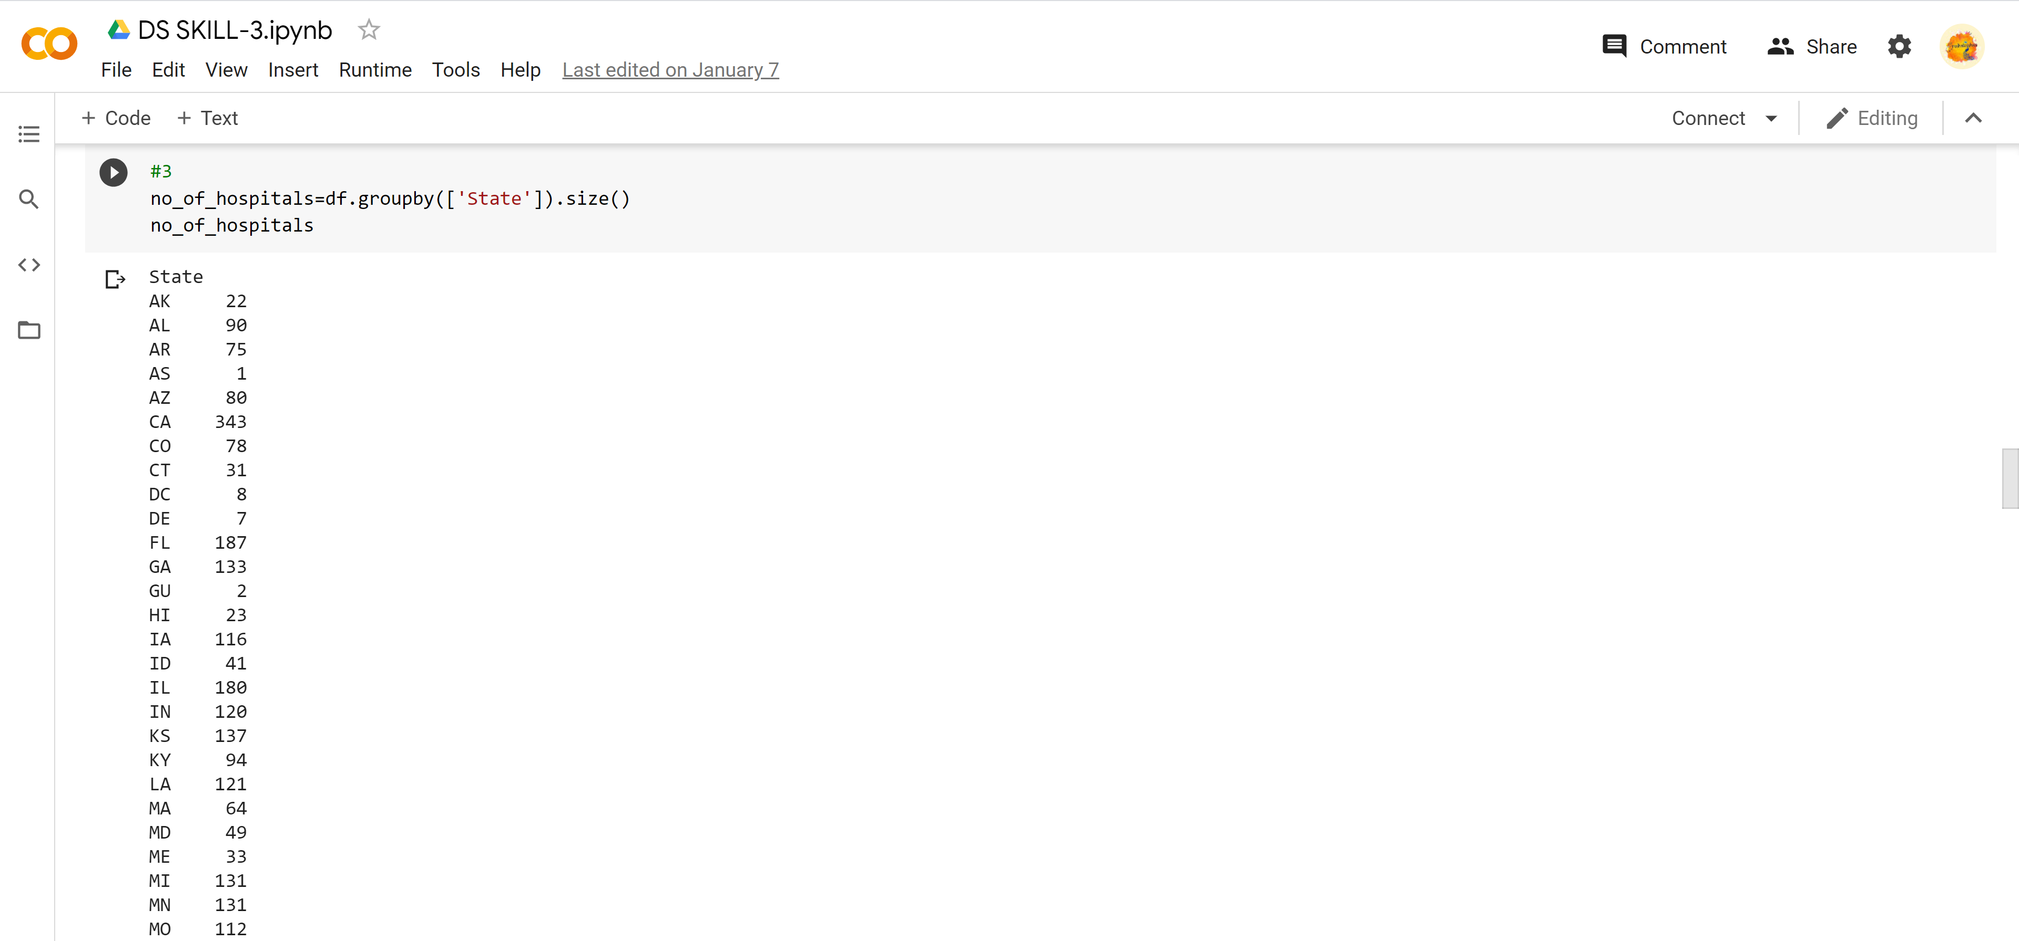

1. County wise hospital numbers in ‘TX’

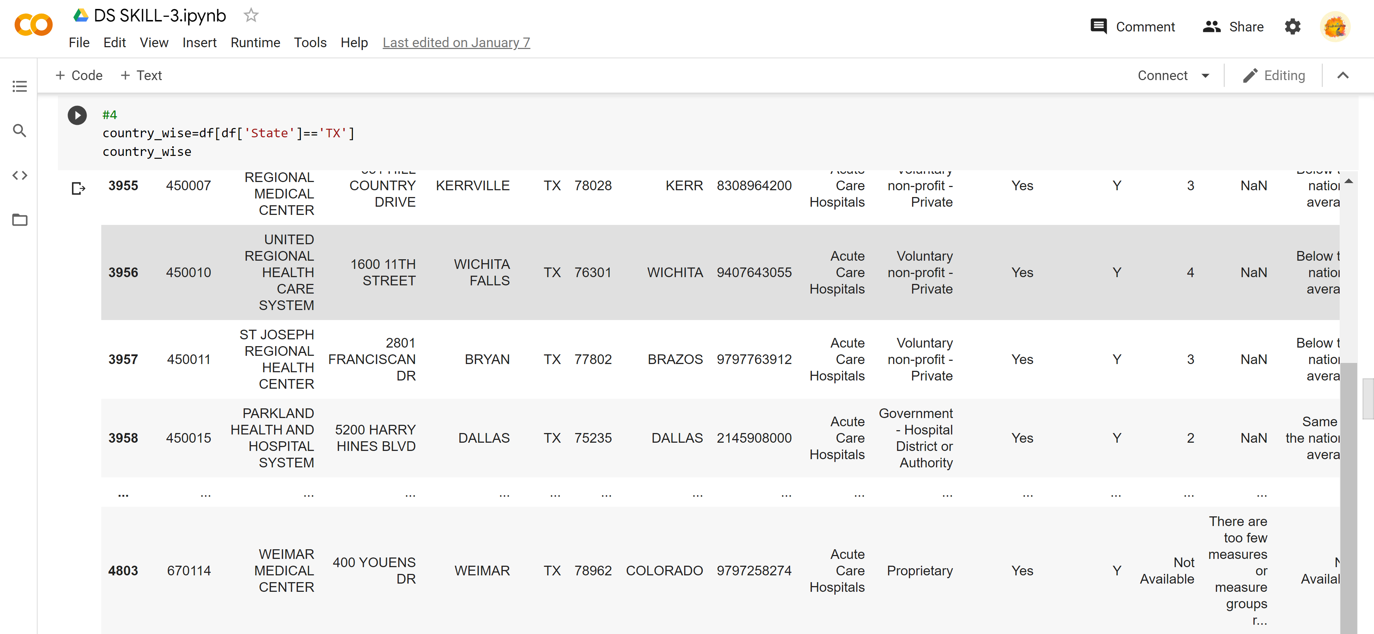

1. Distribution of ‘Hospital Type’ and ‘Ownership in Texas’

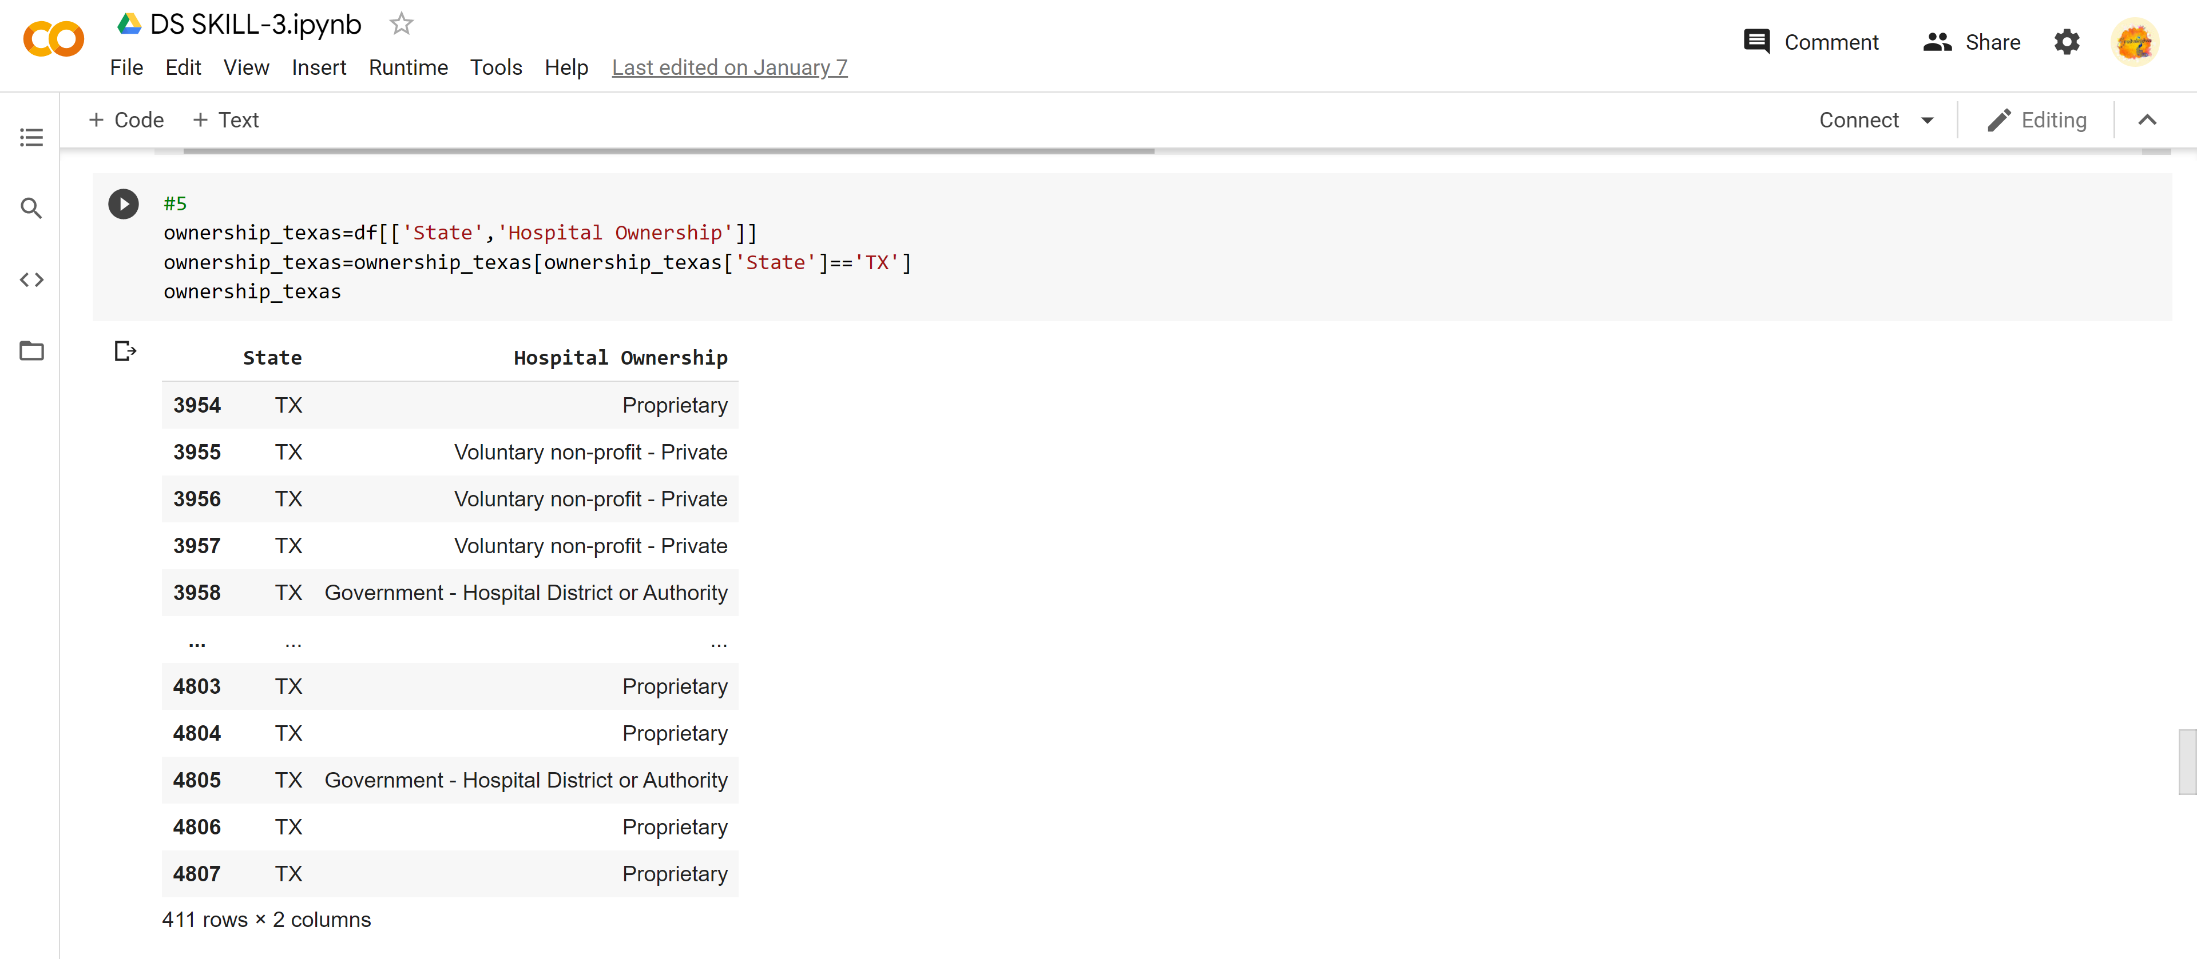

1. Find ‘Timeliness of care national comparison footnote’ and its ‘hospital’

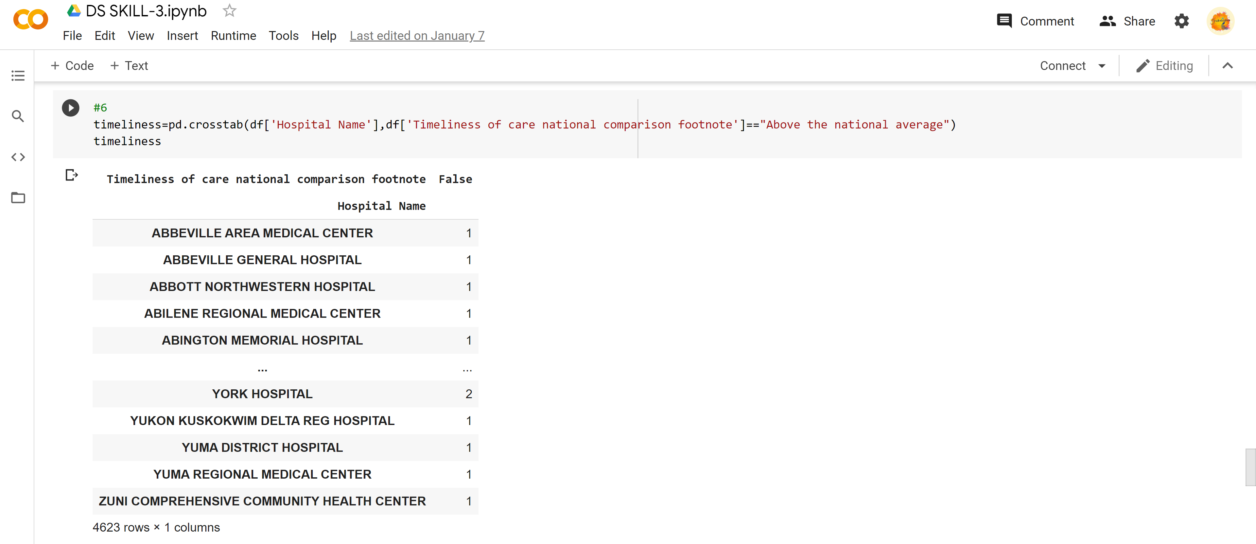

1. ‘Hospital rating’

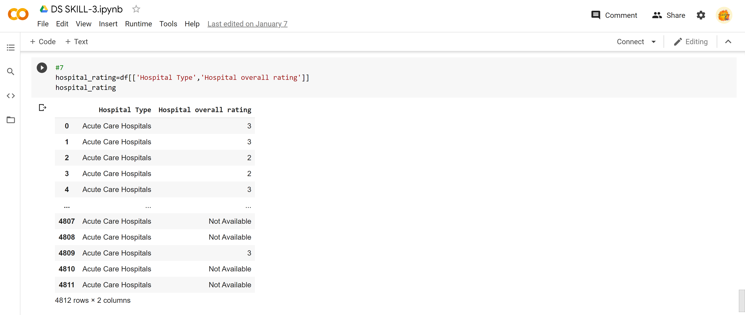

1. Find ‘Acute Care Hospitals’ with rating (4) along with ’state’

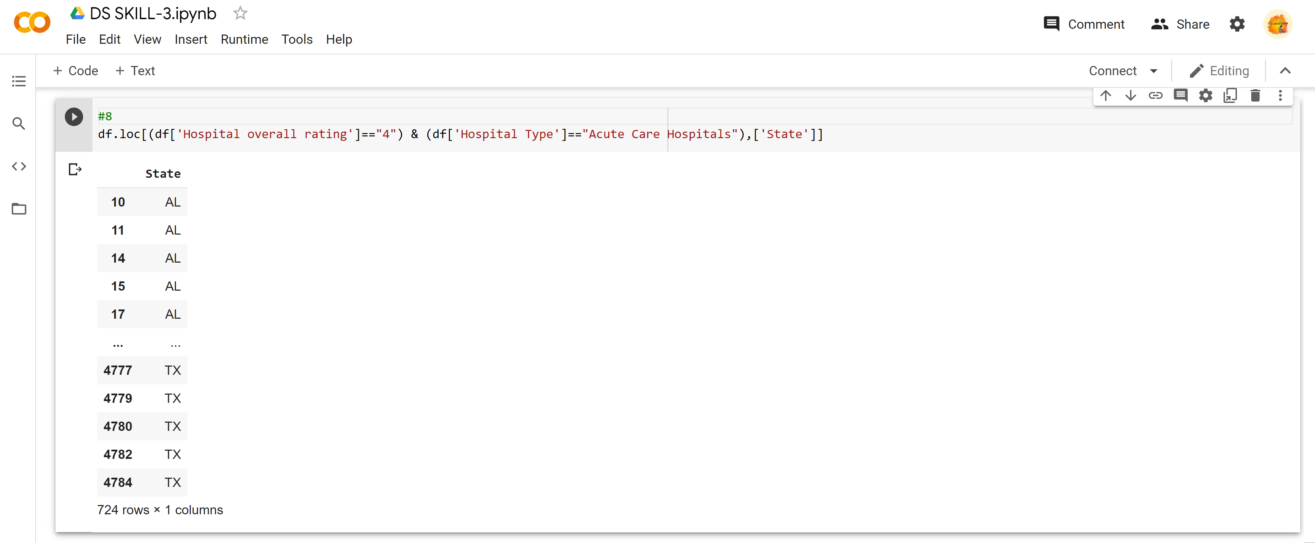

1. Which type of hospitals has highest ‘Non-availability’ of ‘Safety of Care data’?

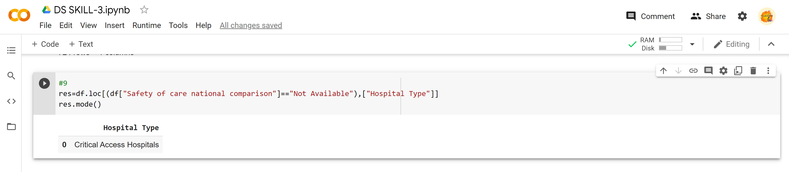

1. What are the different types of ‘Patient experience national comparison’ and list their ‘Provider ID’?

